MySQL for Excel setup / configuration Information

Information:

* Brief Installation and Usage Guides:
  + <https://dev.mysql.com/doc/mysql-for-excel/en/>
  + <https://support.office.com/en-us/article/connect-to-a-mysql-database-power-query-8760c647-88b9-409d-b312-6ea8f84a269b>

System Requirements:

* .NET Framework 4.0 (Client or Full Profile)
  + <https://msdn.microsoft.com/en-us/library/5a4x27ek(v=vs.100).aspx>
  + MySQL Installer requires Microsoft .NET Framework 4.5.2 or later.
  + https://www.microsoft.com/en-us/download/details.aspx?id=42643
* Microsoft Office Excel 2007 or later, for Microsoft Windows.
  + Must enable Developer tab
  + VBA code samples missing / incorrect on the internet. Refer to MSDN Docs
* Visual Studio 2010 Tools for Office Runtime. MySQL Installer may install this for you.
  + <https://www.microsoft.com/en-us/download/details.aspx?id=48217>
* MySQL installer for Windows :
  + <https://dev.mysql.com/doc/mysql-for-excel/en/mysql-for-excel-install.html>
  + The installer is a maintenance tool as well as an installation wizard
  + <https://dev.mysql.com/doc/refman/5.7/en/mysql-installer-setup.html>
  + MySQL Installer 8.0.11 -- Windows (x86, 32-bit), MSI Installer
  + used the mysql-installer-**web**-community file because I had active internet access
  + I performed a full install to get all the options
  + Manually installed the packages that the installer flagged

Usage:

* General coding information
  + <https://en.wikibooks.org/wiki/Excel_VBA>
* Import data from external data sources (Power Query)
  + <https://support.office.com/en-us/article/import-data-from-external-data-sources-power-query-be4330b3-5356-486c-a168-b68e9e616f5a>
* Import Data from Database using Native Database Query (Power Query)
  + <https://support.office.com/en-us/article/import-data-from-database-using-native-database-query-power-query-f4f448ac-70d5-445b-a6ba-302db47a1b00>

Actual Installation:

* I wasn’t sure what the exact difference was between MySQL “developer” mode and “full” mode was and I wanted to ensure that I had all the necessary tools to work with, so I installed “full” mode.
* The “full” mode requires Visual Studio to run. Yet again, I wasn’t sure what the minimum necessary for VS was so I installed everything -- HUGE download and installation that took hours. Went to bed and left it running overnight.
* The “full” mode requires Python 3. That was a simple download and install.
* I installed the standalone MySQL server / Classic MySQL Replication option.

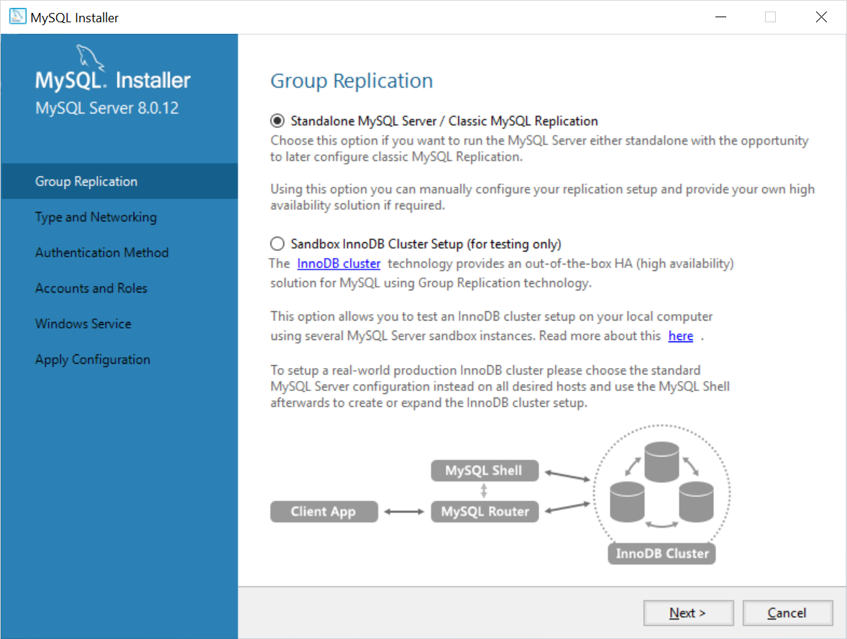

* There are several options for the configuration type:
  + For my purposes, I installed as Development Computer.
* 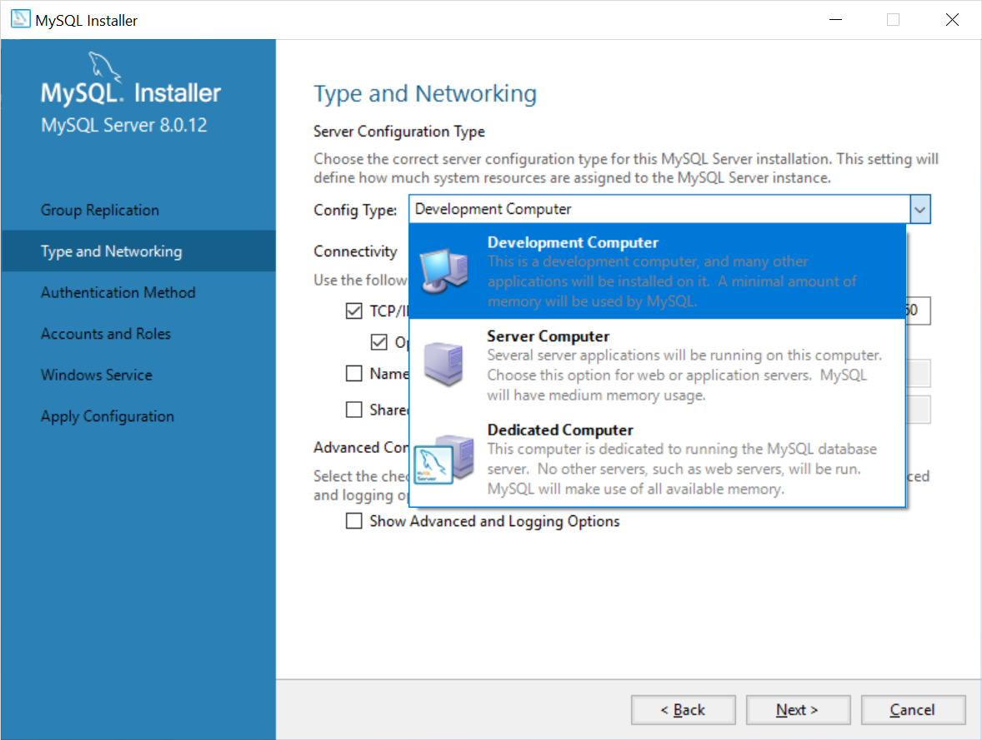
* MySQL missing from Excel.
* https://dev.mysql.com/doc/connector-odbc/en/connector-odbc-examples-tools-with-wordexcel.html
* 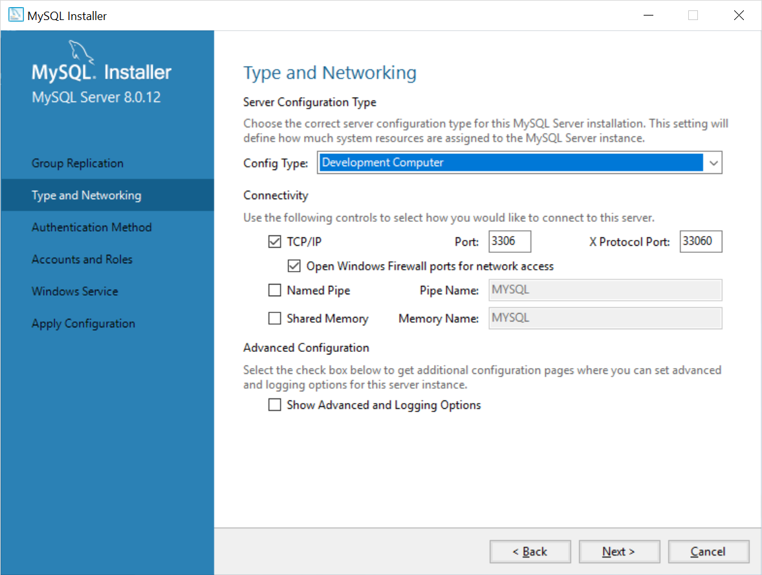
* MySQL supports different Authentication Methods. I set it to use strong password encryption:
* 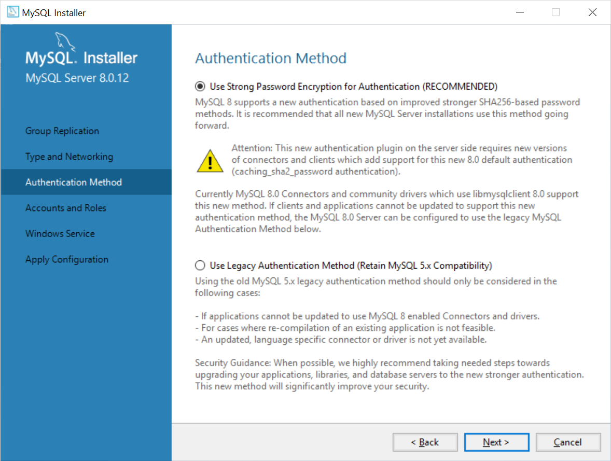
* Stuff I had to set that I didn’t understand:
* 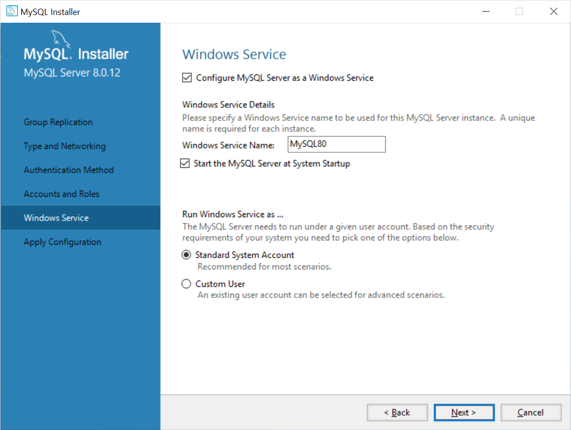
* Gave permission to MySQL to write the changes to Windows
* 
 